**Computer Networking**

**Notes by MOHAMMAD EMRAN AHMED EMON**

**BSc in SOFTWARE ENGINEERING,**

**SHAHJALAL UNIVERSITY OF SCIENCE AND TECHNOLOGY, SYLHET.**

**Registration No: 2020831040**

**Session: 2020-21**

**Organizing Secretary, SWE Society**

**Former Assistant Publication Secretary, SPORTS SUST**

**Former Executive Member, SWE Society**

**Start: 01 Nov 2024**

**End: 17 Nov 2024**

**Introduction to Networks**

**9.0 Introduction**

**9.1 Subnetting an IPv4 Network**

**9.2 Addressing Schemes**

**Subnetting**

**Subnetting** is the process of segmenting a larger network into multiple smaller networks called subnetworks or subnets.

**Reasons for Subnetting:**

Large networks must be segmented into smaller subnetworks, creating smaller groups of devices and services to:

• Control traffic by containing broadcast traffic within each subnetwork.

• Reduce overall network traffic and improve network performance.

**Communication Between Subnets**

▪ A router is necessary for devices on different networks and subnets to communicate.

▪ Each router interface must have an IPv4 host address that belongs to the network or subnet that the router interface is connected.

▪ Devices on a network and subnet use the router interface attached to their LAN as their default gateway

**Basic Subnetting**

Subnets are created by using one or more of the host bits as network bits.

▪ This is done by borrowing some of the bits from the host portion of the address.

▪ The more host bits borrowed; the more subnets can be created. ▪ For each bit borrowed, the number of subnetworks available is doubled.

▪ For example, if 1 bit is borrowed, 2 subnets can be created. If 2 bits, 4 subnets are created, if 3 bits are borrowed, 8 subnets are created, and so on (2n; where n is the number of borrowed bits).

▪ However, with each bit borrowed, fewer host addresses are available per subnet

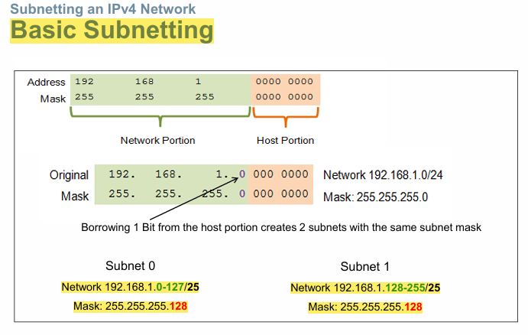

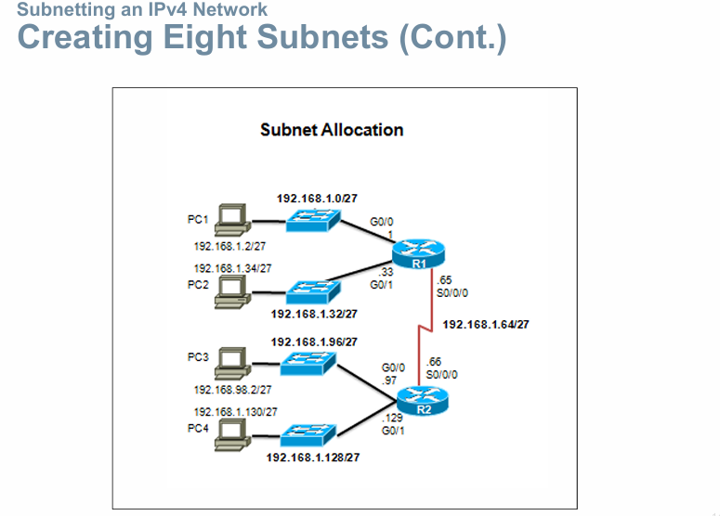

**Two considerations when planning subnets:**

▪ Number of subnets required

▪ Number of host addresses required

**Formula to determine number of usable hosts: 2n-2**

▪ 2n (where n is the number of remaining host bits) is used to calculate the number of hosts.

▪-2 (The subnetwork address and broadcast address cannot be used on each subnet.)

Calculate the number of subnets:

▪ 2n (where n is the number of bits borrowed)

▪ Subnet needed for each department.

Let’s examine the animation in 9.1.4.1

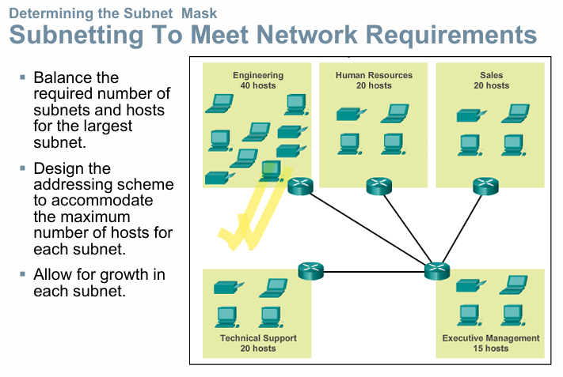

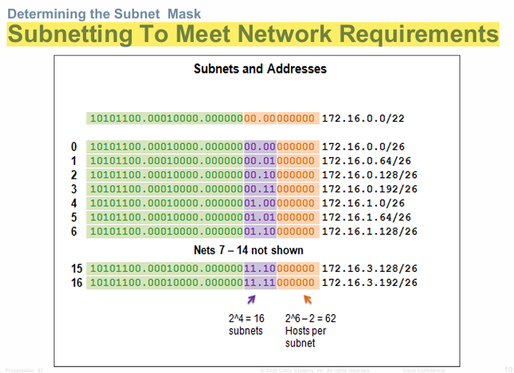

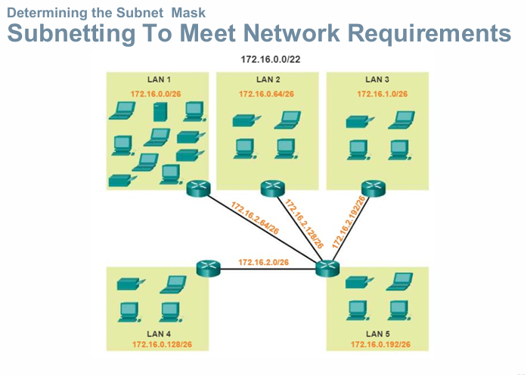

**Variable Length Subnet Masks (VLSM)**

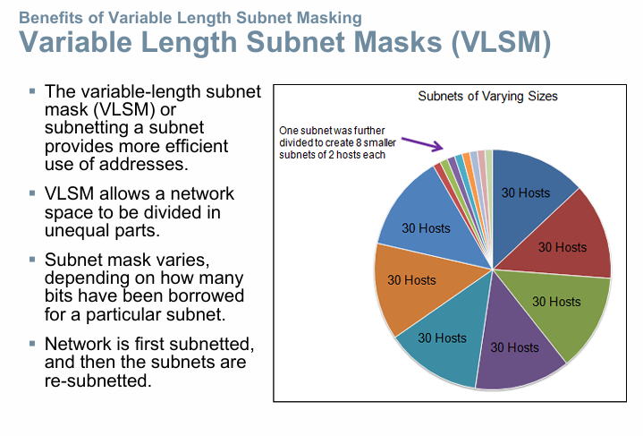

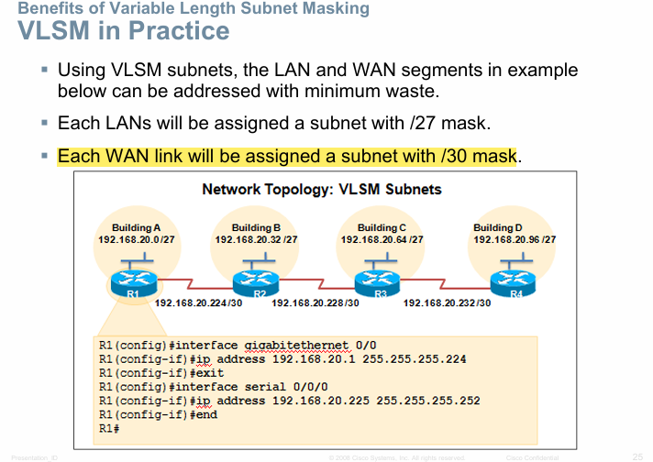

**IP Addressing**

[An IP address (Internet Protocol address) is a numerical label assigned to a device connected to a computer networ](https://www.bing.com/ck/a?!&&p=14a2b2829bafac3ad7d1cf6b5b24cb141394f71b0fcb20102f02a6feb1831575JmltdHM9MTczMDU5MjAwMA&ptn=3&ver=2&hsh=4&fclid=32a5eee7-1480-6593-2bd2-fbf1151b6403&psq=what+is+ip+address&u=a1aHR0cHM6Ly9lbi53aWtpcGVkaWEub3JnL3dpa2kvSVBfYWRkcmVzcw&ntb=1)k that uses the [Internet Protocol](https://en.wikipedia.org/wiki/Internet_Protocol) for communication.

IP addresses serve two main functions:

network interface [identification](https://en.wikipedia.org/wiki/Identification_(information)),

and location [addressing](https://en.wikipedia.org/wiki/Network_address).

**Types of IP addresses**

There are several types of IP addresses, each with different purposes and characteristics. Here’s a look at each of them, what they’re used for, and how they work:

**Public IP addresses**

Public IP addresses are what devices and servers use to communicate over the internet. Your internet service provider (ISP) assigns a public IP address to your router. Then your router assigns your device and other devices connected to it with their own individual IP address.

**Private IP addresses**

A private IP address, also called a local IP address, is the IP address used to identify each device within your local network. While your public IP address is visible to devices outside your network, your private IP address is only visible within your network

**Static IP addresses**

Static IP addresses don’t change; once a device is assigned an IP address, that address remains the same. Static IP addresses are often used for large servers or other central devices

**Dynamic IP addresses**

Most devices use dynamic IP addresses, which change over time—how often varies depending on the ISP and other factors. A dynamic IP address offers security benefits, because changing IPs are harder to hack or spoof.

**IPv4 Network Addresses**

**IP Address and Address Space**

* The identifier used in the IP layer of the TCP/IP protocol suite to identify the connection of each device to the Internet.
* An IPv4 address is a 32-bit address that uniquely and universally defines the connection of a host or a router to the Internet.
* The IP address is the address of the connection, not the host or the router because if the device is moved to another network, the IP address may be changed
* Address Space: An address space is the total number of addresses used by the protocol
* If a protocol uses b bits to define an address, the address space is 2b because each bit can have two different values (0 or 1)
* IPv4 uses 32-bit addresses, which means that the address space is 232 or 4,294,967,296 (more than four billion)

**IPv4 Address Structure Binary Notation**

* Binary notation refers to the fact that computers communicate in 1s and 0s
* For ease of use by people, binary patterns representing IPv4 addresses are expressed as dotted decimals.
* This is first accomplished by separating each byte (8 bits) of the 32-bit binary pattern, called an octet, with a dot.

What is Subnet Mask?

[A subnet mask is a 32-bit number that defines a range of IP addresses available within a network](https://www.bing.com/ck/a?!&&p=90acd301c7046d353b3c2990d7e7a47dab601324cbea37fdc615baa75e7dbb65JmltdHM9MTczMDY3ODQwMA&ptn=3&ver=2&hsh=4&fclid=32a5eee7-1480-6593-2bd2-fbf1151b6403&psq=what+is+subnet+mask&u=a1aHR0cHM6Ly90ZWNodGVybXMuY29tL2RlZmluaXRpb24vc3VibmV0X21hc2s&ntb=1). [It distinguishes the network address and the host address within an IP address](https://www.bing.com/ck/a?!&&p=9f9ca0cbb60086711e74b91278775697a69f7cc3176a2a1d5d505ea5915ba520JmltdHM9MTczMDY3ODQwMA&ptn=3&ver=2&hsh=4&fclid=32a5eee7-1480-6593-2bd2-fbf1151b6403&psq=what+is+subnet+mask&u=a1aHR0cHM6Ly93d3cuaXB4by5jb20vYmxvZy93aGF0LWlzLXN1Ym5ldC1tYXNrLw&ntb=1). [It is made by setting network bits to all "1"s and setting host bits to all "0"s](https://www.bing.com/ck/a?!&&p=a718161c58ecf5ed3c5ae6cf2a031a42068772d84a3a30c905e651433b609d0cJmltdHM9MTczMDY3ODQwMA&ptn=3&ver=2&hsh=4&fclid=32a5eee7-1480-6593-2bd2-fbf1151b6403&psq=what+is+subnet+mask&u=a1aHR0cHM6Ly93d3cuaXBsb2NhdGlvbi5uZXQvc3VibmV0LW1hc2s&ntb=1)

[A subnet mask is used to divide a network into smaller subnets](https://www.bing.com/ck/a?!&&p=9f9ca0cbb60086711e74b91278775697a69f7cc3176a2a1d5d505ea5915ba520JmltdHM9MTczMDY3ODQwMA&ptn=3&ver=2&hsh=4&fclid=32a5eee7-1480-6593-2bd2-fbf1151b6403&psq=what+is+subnet+mask&u=a1aHR0cHM6Ly93d3cuaXB4by5jb20vYmxvZy93aGF0LWlzLXN1Ym5ldC1tYXNrLw&ntb=1). [It is not shown inside the data packets traversing the Internet](https://www.bing.com/ck/a?!&&p=5588bfb016723fe57d8a29e00034b52af590ef556decd05bef307e399931b313JmltdHM9MTczMDY3ODQwMA&ptn=3&ver=2&hsh=4&fclid=32a5eee7-1480-6593-2bd2-fbf1151b6403&psq=what+is+subnet+mask&u=a1aHR0cHM6Ly93d3cuZ3VydTk5LmNvbS9zdWJuZXR0aW5nLXN1Ym5ldC1tYXNrLmh0bWw&ntb=1)

**IPv4 Subnet Mask Network Portion and Host Portion of an IPv4 Address**

* To define the network and host portions of an address, a device uses a separate 32-bit pattern called a subnet mask
* The subnet mask does not actually contain the network or host portion of an IPv4 address, it just says where to look for these portions in a given IPv4 address

**Types of IPv4 Address**

**Classful Addressing**

* The whole Address space was divided into five classes (Class A, B, C, D and E)
* The unicast address classes A, B, and C defined specifically sized networks and specific address blocks for these networks.
* A company or organization was assigned an entire network from class A, class B, or class C address block.
* This use of address space is referred to as classful addressing.
* It also defined class D (multicast) and class E (experimental) addresses, as previously presented.

**Types of IPv4 Address**

**Classless Addressing**

**Limits to the Class-based System**

* Not all organizations' requirements fit well into one of these three classes.
* Classful allocation of address space often wasted many addresses, which exhausted the availability of IPv4 addresses.
* For example, a company that had a network with 260 hosts would need to be given a class B address with more than 65,000 addresses

**Classless Addressing/Prefix length**

* Formal name is Classless Inter-Domain Routing (CIDR, pronounced “cider”)
* Created a new set of standards that allowed service providers to allocate IPv4 addresses on any address bit boundary (prefix length) instead of only by a class A, B, or C address

**Prefix Length**

* The prefix length is another way of expressing the subnet mask.
* The prefix length is the number of bits set to 1 in the subnet mask.
* It is written in “slash notation”, a “/” followed by the number of bits set to1.
* For example, if the subnet mask is 255.255.255.0, there are 24 bits set to 1 in the binary version of the subnet mask, so the prefix length is 24 bits or /24.
* The prefix and the subnet mask are different ways of representing the same thing - the network portion of an address.

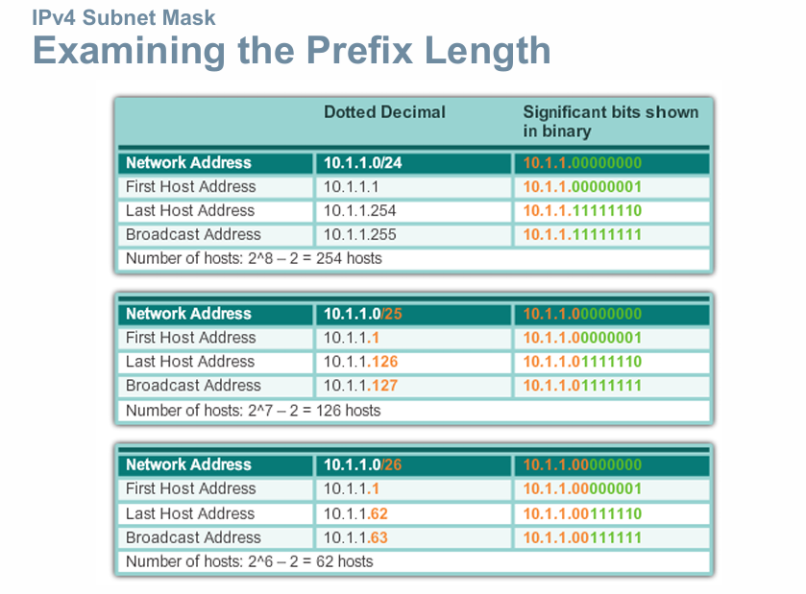

**IPv4 Unicast, Broadcast, and Multicast**

In an IPv4 network, the hosts can communicate one of three different ways: **Unicast**, **Broadcast**, and **Multicast**

**#1/Unicast**

the process of sending a packet from one host to an individual host.

**#2 Broadcast**

the process of sending a packet from one host to all hosts in the network.

**Directed broadcast**

▪ Destination 172.16.4.255

▪ Hosts within the 172.16.4.0/24 network

**Limited broadcast**

▪ Destination 255.255.255.255

▪ NOTE: Routers do not forward a limited broadcast!

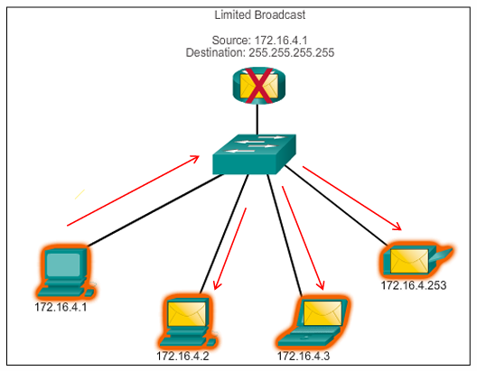

**#3 Multicast–**

The process of sending a packet from one host to a selected group of hosts, possibly in different networks.

▪ Reduces traffic

▪ Some examples: Video and audio broadcasts, Routing information exchange, Distribution of software, Remote gaming

▪ Reserved for addressing multicast groups – 224.0.0.0 to 239.255.255.255.

▪ Link local – 224.0.0.0 to 224.0.0.255 (Example: routing information exchanged by routing protocols)

**What is Private IP Addressing?**

Private IP Addresses are those addresses that work within the local network. These addresses are non-routable on the Internet. The address is basically assigned by the network router to your particular device. The unique private IP address is provided to every device which is on the same network. In this way, devices communicate with one another on the same network without connecting to the entire Internet. In this way, Private IP addresses are able to provide more security within a particular network. The private IP address cannot be seen on the Internet, unlike the Public IP Address. Only devices within the local network are able to see the address of one another

**Private address blocks are:**

Hosts that do not require access to the Internet can use private addresses reserved by the **Internet Assigned Numbers Authority (IANA)**

▪ 10.0.0.0 to 10.255.255.255 (10.0.0.0/8) Class-A

▪ 172.16.0.0 to 172.31.255.255 (172.16.0.0/12) Class-B

▪ 192.168.0.0 to 192.168.255.255 (192.168.0.0/16) Class-C

**Shared address space addresses**:

▪ Not globally routable

▪ Intended only for use in service provider networks

▪ Address block is 100.64.0.0/10

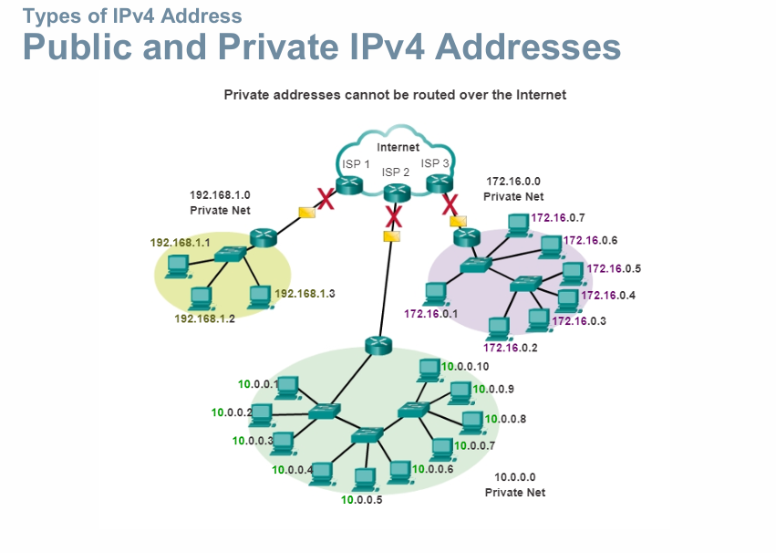

**Public address:**

▪ Public IP address of a system is the IP address which is used to communicate outside the network.

▪ Public IP address is basically assigned by the **ISP (Internet Service Provider).**

▪ Besides private IP addresses, rest are public

**What is a Public IP Address?**

In a computer network, a Public IP address is defined as a unique numerical value that is assigned to the particular device connected in the network that makes use of internet protocol for communication and transmission.

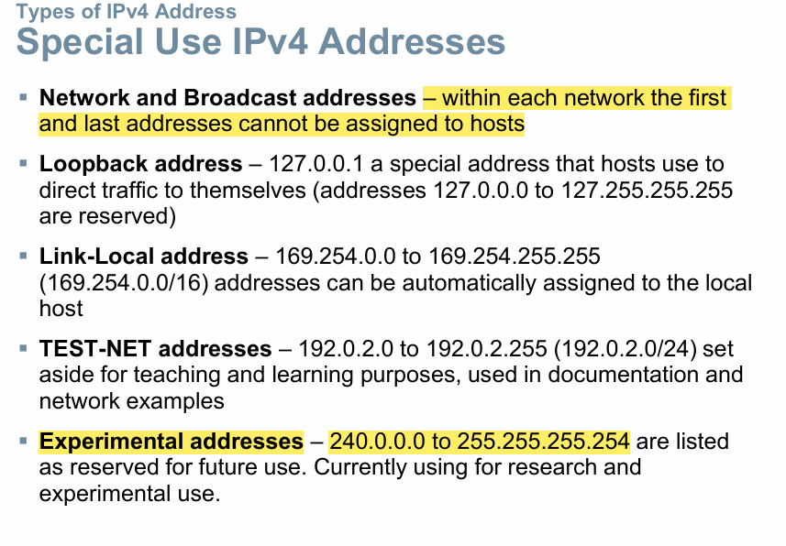

why the first and last address cannot be assigned in network?

In a network, the first and last IP addresses are reserved for special purposes and cannot be assigned to individual devices:

1. **Network Address**: The first address in a subnet is known as the network address. It identifies the entire network and **is used by routers to determine the destination network** for data packets. [This address has all zeros in the host part of the IP address](https://dev.to/codexam/how-to-find-the-first-and-last-address-in-a-block-of-ip-addresses-and-understand-subnetting-53f4).
2. **Broadcast Address**: The last address in a subnet is the broadcast address. It is **used to send data to all devices on the network simultaneously**. [This address has all ones in the host part of the IP address](https://community.cisco.com/t5/switching/why-is-the-first-address-on-a-subnet-reserved/td-p/1896044).

[These reservations help in managing and routing network traffic efficiently, ensuring that data packets reach their intended destinations without confusion](https://community.cisco.com/t5/routing/ip-address-rejection/td-p/4731108).

**IPv6 Network Addresses**

**why IPv6 does not have broadcast addresses?**

IPv6 does not have broadcast addresses because it was designed to be more efficient and scalable than IPv4, addressing the limitations and inefficiencies of IPv4 broadcasts. Here’s why IPv6 omits broadcast addresses:

1. **Reduced Network Traffic with Multicast**
2. **Improved Network Efficiency**
3. **Enhanced Security and Control**
4. **Alternative IPv6 Addressing Types for Specific Purposes**

**what happens when a packet arrives on router interface?**

When a packet arrives on a router interface, the router examines the packet's header, particularly the destination IP address, and uses its routing table to determine the best path to forward the packet towards its intended destination network, essentially deciding where to send the packet next based on its configured routes; if the destination is on the same network, the packet is directly delivered, otherwise, it's forwarded to the next hop in the path

1. **Check the IP header**

The router looks at the packet's IP header to find the destination IP address.

1. **Check the routing table**

The router uses the routing table to see if the destination is on one of its attached networks or if it needs to be forwarded to another router.

1. **Send the packet**

The router sends the packet to the next system in the path to the destination

**1. Receiving the Packet at the Interface**

* The router interface receives the packet, which arrives as a series of bits over a physical or wireless link.
* The interface converts the bits into a complete packet and examines the **link-layer header** to see where it’s coming from.

**2. Decapsulating the Link-Layer Header**

* The router removes (decapsulates) the **link-layer header** from the packet, which contains information about the physical network.
* Once this header is removed, the router is left with the **network-layer packet** (usually an IP packet).

**3. Inspecting the Destination IP Address**

* The router then checks the **destination IP address** in the IP header of the packet.
* This destination address determines where the packet is ultimately supposed to go.

**4. Looking Up the Routing Table**

* The router consults its **routing table**, which contains paths and next-hop information for different destination networks.
* The router looks for the **longest prefix match** for the destination IP in its routing table, meaning it finds the most specific entry that matches the destination address.

**5. Making a Forwarding Decision**

* Based on the routing table, the router decides on the **next hop** (the next router or destination network) for the packet.
* If the packet’s destination matches a **directly connected network**, the router forwards the packet directly to the device on that network.
* If the destination is on a different network, the router forwards it to the next hop specified in the routing table.

**6. Re-Encapsulating the Packet in a New Link-Layer Header**

* The router re-encapsulates the packet with a new link-layer header for the next hop.
* This new header includes the **MAC address** of the next hop if it’s on the same data link, ensuring it reaches the correct next device in the chain.

**7. Sending the Packet Out the Correct Interface**

* The router sends the re-encapsulated packet out through the interface specified in the routing table entry.
* The packet leaves the router on this outbound interface, heading towards its next destination (either the next router or the final device if it’s on the destination network).

**Computer Networking Lab Practices**

**Connection Types:**

Ethernet Stright Through Cable-> for connecting two different devices

Ethernet Crossover-cable-> for connecting same type of devices

**1. Copper Straight-Through Cable**

* **Purpose**: Used to connect different types of devices, such as PCs to switches or routers to switches.
* **Connects**:
  + End devices to network devices (e.g., PC to switch).
  + Different types of devices.
* **Cable Type**: Ethernet (e.g., Cat5/Cat6).
* **Port**: Ethernet ( FastEthernet or GigabitEthernet ).

**2. Copper Crossover Cable**

* **Purpose**: Used to connect similar types of devices, such as PC to PC or switch to switch.
* **Connects**:
  + Router to router.
  + PC to PC.
  + Switch to switch (when interconnecting).
* **Cable Type**: Ethernet crossover cable.
* **Port**: Ethernet.

**Command Prompt:**

* **ipconfig -just ip address**
* **ipconfig /all - ip+physical address**
* **ping 192.168.0.1 -will check the connection**
* **show mac-address-table**
* **ip helper-address 192.168.2.2**
* **en**
* **conf t**
* **int g0/0**
* **ip add 10.0.0.1 255.255.255.0 //assigning ip to router**
* **no shut**

**SOME BASICS FACTS**-

* **SWITCH/HUBS**-> connects multiple devices in LAN
* **Hubs** connects all devices of a LAN network, that means it is STAR TOPOLOGY.

**Why We Use NAT (Network Address Translation) in Cisco Packet Tracer?**

1. When devices have Private Ip Address (Range: 10.0.0.0 to 10.255.255.254, 192.168.0.0 to 192.168.255.255, 172.16.0.0 to 172.31.255.255), they are unable to access to the internet. We use NAT on the router so that these devices can be able to access to the internet.

**NAT (Network Address Translation)** is a technology used on routers to allow devices with private IP addresses to communicate with the external internet or other networks. Here's why it's necessary:

**Reason for Using NAT:**

i. **Private IP Addresses Cannot Access the Internet Directly**:

* Devices in a local network often use private IP addresses (ranges: 10.0.0.0 to 10.255.255.254, 192.168.0.0 to 192.168.255.255, 172.16.0.0 to 172.31.255.255).
* **Private IP addresses** are not routable on the public internet because they are reserved for use within private networks only.
* **Public IP addresses** are needed for communication over the internet.

ii. **NAT Translates Private to Public IP**:

* NAT is configured on a router to map private IP addresses to a public IP address or a pool of public IP addresses.
* This translation enables devices with private IPs to communicate with the internet while appearing to have a valid public IP address.

**Benefits of Using NAT:**

* **Conservation of Public IPs**: NAT helps reduce the need for a unique public IP for every device, conserving the limited pool of public IPv4 addresses.
* **Enhanced Security**: NAT hides the internal network structure, adding a layer of security because external devices only see the router's public IP, not the internal IPs.
* **Internet Access for Private Networks**: By translating private IPs to public ones, NAT allows devices in a local network to access the internet.

**How NAT Works in Cisco Packet Tracer:**

1. **Configuration on Router**: NAT is set up on the router that connects the internal private network to the external network (e.g., the internet).
2. **Translation Process**:
   * When an internal device sends a packet to the internet, the router translates the source private IP address to its public IP address.
   * When the response comes back, the router translates the public IP address back to the original private IP and forwards it to the device.
3. **Types of NAT**:
   * **Static NAT**: Maps a specific private IP address to a specific public IP address.
   * **Dynamic NAT**: Maps private IP addresses to a pool of public IP addresses.
   * **PAT (Port Address Translation)**: Also called **NAT Overload**, it maps multiple private IP addresses to a single public IP address using different port numbers.

**1.Static NAT Configuration**

Maps a specific private IP address to a specific public IP address

*Commands to set Static NAT on Router*

**#int g0/0**

**#ip nat outside**

**#int g0/1**

**#ip nat inside**

**#exit**

//static NAT mapping

**#ip nat inside source static 172.16.0.1 100.0.0.1**

**#ip nat inside source static 172.16.0.2 100.0.0.2**

**#exit**

//NAT translation and statistics

**#show ip nat translation**

**#show ip nat statistics**

//pinging from device, then check again ip nat transalation

**#ping 8.8.8.8** //from pc1

**#ping 8.8.8.8** //from pc2

//after showing new ip nat transalation table, clear ip nat transalation, and see what remains?

**#clear ip nat transalation \***

It will only the static entries on the ip nat translation table. The dynamic entries will vanish after a certain time, only the STATIC entries will remain.

**Why the Outside Local and Outside Global IP remains same on NAT processing?**

In NAT (Network Address Translation) processing, **Outside Local** and **Outside Global** IP addresses typically remain the same because they both represent the IP address of the destination device on the external network (e.g., the internet)

**Definitions:**

* **Outside Local IP**: This is the IP address of an external device (e.g., a web server) as it appears from the internal network's perspective. It is used when devices inside the local network communicate with outside devices.
* **Outside Global IP**: This is the real, publicly routable IP address of the external device on the internet.

**Why They Remain the Same:**

* **Publicly Routable**: The outside IP (both local and global) is already a public IP address. There is no need for translation because it does not conflict with private IP spaces.
* **Unchanged by NAT**: NAT only alters the internal (local) private IPs to public (global) IPs for outgoing traffic and vice versa. The external destination IP (outside local/global) is simply passed through without modification.

**What is the functionality of POOL?**

Pool refers to a range of IP addresses for assigning. Imagine a small office network where the DHCP server is configured with a pool of IP addresses ranging from 192.168.1.100 to 192.168.1.200. A new laptop connects to the network and sends a DHCP request. The DHCP server assigns the first available IP, say 192.168.1.100, to the laptop.

**Analogy for Simplicity**: Think of the **DHCP pool** like a parking lot with numbered spaces (192.168.1.100 to 192.168.1.200). As cars (devices) arrive, they are assigned a spot. Once they leave, that spot becomes available for the next car

**How the pool maps into private ip in dynamic NAT? Explain the working mechanism.**

In **dynamic NAT**, a pool of public IP addresses is configured on the router to be shared among multiple private IP addresses. Here’s how the mechanism works:

1. **Configuration of the Pool**: A range of public IP addresses is defined as a pool in the router configuration. For example, a pool might consist of public addresses from 203.0.113.1 to 203.0.113.10.
2. **Mapping Process**:
   * When a device with a private IP (e.g., 192.168.1.10) tries to access the internet, the router checks if there is an available public IP in the pool.
   * If an available public IP is found, the router temporarily maps the private IP (192.168.1.10) to one of the public IPs (e.g., 203.0.113.3).
   * This mapping is maintained in a NAT table to keep track of which private IP is using which public IP for returning traffic.
3. **Communication Flow**:
   * Outbound traffic from the private IP is sent with the public IP as its source address.
   * When the response returns from the internet, the router consults the NAT table to map the public IP (203.0.113.3) back to the corresponding private IP (192.168.1.10).
4. **Example**:
   * **Private IPs**: 192.168.1.10, 192.168.1.11
   * **Public Pool**: 203.0.113.1 to 203.0.113.10
   * When 192.168.1.10 initiates a connection, it could be assigned 203.0.113.3 from the pool.
   * If 192.168.1.11 initiates a connection afterward, it could be assigned 203.0.113.4, and so on.

This allows multiple devices to share a limited pool of public IP addresses, facilitating efficient use of IPs while enabling private network devices to communicate over the internet.

**2.Dynamic NAT Configuration**

Maps private IP addresses to a pool of public IP addresses.

Commands to configure Dynamic NAT

**#en**

**#conf t**

**#int g0/0**

**#ip nat outside**

**#int g0/1**

**#ip nat inside**

//Now if you want to translate all traffic from 172.16.0.0/24, so let’s create an **Access List** that matches that source IP.

**#access-list 1 permit 172.16.0.0 0.0.0.255**

**#ip nat inside pool POOL1 10.0.0.1 to 10.0.0.2 netmask 255.255.255.0 //ip range**

**#ip nat inside source list 1 pool POOL1**

**#do show ip nat translations**

**#do clear ip nat translation \***

**#do show run | include nat**

**#ip nat inside source list 1 interface g 0/0 overload**

**#do show run | include nat**